# PROBLEM STATEMENT AND FORMULATION

## PROBLEM STATEMENT

Presently an analog setup is used in Hindustan Aeronautics Limited. It consists of fuel reserve, FCG electronic test kit, a fixed power supply unit and CRO.

This setup involves some problems as follows:

* Parallax error.
* Particles exceeding ½ inch diameter can be problematic.
* Changes in temperature of liquid results in shift of di electric constant.
* Time consuming.
* Requires more man power.
* Equipment used requires takes more space for installation.

## PROBLEM FORMULATION

The changes in the temperature of liquid results in shift of the dielectric constant which results in lots of problems as it lead to change of the readings for every fraction change of temperature. Due to so many short comings analog setup is time consuming. Thus to overcome all these shortcoming we switch to completely automated digitalized setup.

* Two microcontrollers (Arduino Uno) are used. One is to read the analog frequency and the same is converted to digital frequency, height of using suitable codes. Second controller is used to implement PID control of height of fuel in the tank using three phase AC motor.
* Time period, height are displayed on a 16 x 2 LCD. Final metrology of the probe is printed on a graphical user interface (GUI) using serial communication ports.
* A buzzer and low level warning on display have been introduced along with LED.
* Two relays are also used to control the motor.

## Discussion of the problem

Presently an analog setup is being used in Hindustan Aeronautics Limited whose setup consists of FCG tank, fuel reserve, FCG electronic test kit, a fixed power supply unit (28v and 5v) and CRO. The probe from the tank is connected to the test kit.

The supply is given to the FCG electronic test rig. The FCG test tank can test all the five main tanks and the connection is given to the FCG electronic test rig. Upon the selection of tank the content of ATF K-50 i:e; the fuel reserve height is read from the capillary tube attached to the FCG test tank. For the purpose of calculation of the frequency, time-period waveforms are read from the CRO. In this setup operator has to turn on the motor manually and stop it when desired height is reached by checking the capillary tube. Then he should note down the frequency, time-period manually from the CRO. This should be repeated nearly 35 times for metrology of single probe and requires three persons to do the job. One person should operate motor, second person should check the height in capillary tube and one more person should check the CRO for noting down time period and frequency.

In reading the waveform lot of parallax error can be encountered. Particles which are more than half inch diameter can be problematic as they interfere with the di electric constant and density of the liquid. The changes in the temperature of the liquid results in shift of the dielectric constant which results in lots of problems as it lead to change of the readings for every fraction change of temperature. This also requires more man power. Due to so many shortcomings this analog setup is time consuming. Thus to overcome all these we switch to a completely automated digitalized setup.

Most aircraft fuel tanks have numerous fuel quantity probes. Number of probes used can vary depending on tank size and system design. Most common configuration have 6-12 probes. This probes are capacitive transducers. The higher the fuel, the higher the capacitance. Fuel capacitance is read in Pico Farads. Tanks have one probe that measures fuel density. This is a compensator probe. The “comp” probe has a unique function, but its outputs are still read in pf.

# The Fuel Probe Test Box and its Electrical Schematic

# Analog Fuel Probe Test Kit

## Cathode-Ray Oscilloscope (CRO)

Oscilloscopes are used in the sciences, medicine, engineering, automotive and the telecommunications industry. General-purpose instruments are used for maintenance of electronic equipment and laboratory work. It is commonly used to display and analyze the waveform of electronic signals. The basic oscilloscope, as shown in the illustration, is typically divided into four sections: the display, vertical controls, horizontal controls and trigger controls. The display is usually a CRT or LCD panel which is laid out with both horizontal and vertical reference lines referred to as the graticule. In addition to the screen, most display sections are equipped with three basic controls: a focus knob, an intensity knob and a beam finder button. The vertical section controls the amplitude of the displayed signal. This section carries a Volts-per-Division (Volts/Div.) selector knob, an AC/DC/Ground selector switch and the vertical (primary) input for the instrument. Additionally, this section is typically equipped with the vertical beam position knob. The horizontal section controls the time base or "sweep" of the instrument. The primary control is the Seconds-per-Division (Sec/Div) selector switch. Also included is a horizontal input for plotting dual X-Y axis signals. The horizontal beam position knob is generally located in this section.

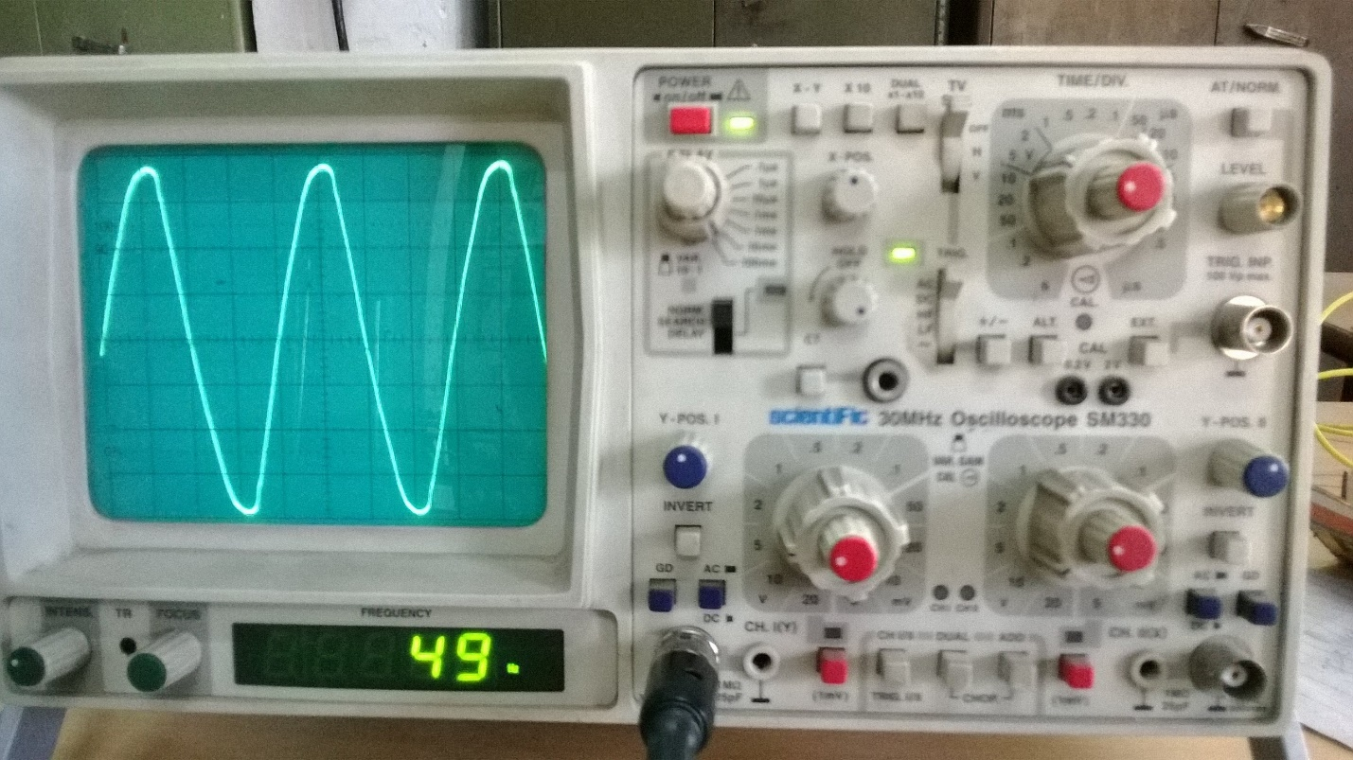

## Regulated DC power supply.

A regulated power supply is an embedded circuit; it converts unregulated AC into a constant DC. With the help of a rectifier it converts AC supply into DC. Its function is to supply a stable voltage (or less often current), to a circuit or device that must be operated within certain power supply limits. The output from the regulated power supply may be alternating or unidirectional, but is nearly always DC. Digital power has come out of the realm of R&D lab and into the main stream. Note that the term “digital power” is often loosely defined with respect to power supply which is digital, otherwise known as switching power supply. This type of supply may utilize either digital or analog methods to control the on/off time of the power MOSFET. Also, analog power supply controllers may make use of digital circuitry for power supply sequencing and tracking, voltage margining, as well as I2C implementations of reading back or fault conditions , such as input/output under voltage and overvoltage, or output short circuit.

Now-a-days designing power supply plays a vital role in any electronic equipment. Power supply must be as compact as possible. It should be free from harmonics and should be reliable in operation. Size of power supply decides the overall size of the electronic device. So one must give vital importance for designing and implementing power supply for any electronic equipment.

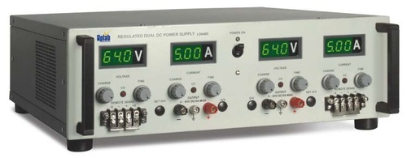

# LITERATURE SURVEY

## Data sheets of Various Tank Probes by HAL Lucknow.

These datasheets indicate the capacity of each tanks and also the calibration table which consists of frequency, height of the probe and height of the fuel. The document also indicated the power rating, tolerance values of different probes. The document are of standard revision 2013.

## Arduino user Manual-Hands on Research in complex system Shanghai Jiao Tong University 17-29, 2012

This manual helps a beginner to get to know about the Arduino boards and start-up with simple programs. This manual also gives the internal structure of the Atmel microcontroller and its specifications in detail.

## FDU user manual Mfd. By Flight Test Centre, Aircraft Research and design center, Hindustan Aeronautics Limited, Bengaluru.

This manual provides the functional description, operation and maintenance procedures for the fuel display unit (FDU) installed in the instrument panel of Advanced Light Helicopter (ALH) cockpit as part of fuel gauging system.

## Proportional Integral Derivative (PID) Control

PID control stands for proportional plus derivative plus integral control. PID control is a feedback mechanism which is used in control system. This type of control is also termed as three term control. By controlling the three parameters - proportional, integral and derivative we can achieve different control actions for specific work. PID is considered to be the best controller in the control system family. For PID control the actuating signal consists of proportional error signal added with derivative and integral of the error signal. Therefore, the actuating signal for PID control is –



There are some control actions which can be achieved by using any of the two parameters of the PID controller. Two parameters can work while keeping the third one to zero. So PID controller becomes sometimes PI (Proportion integral), PD (proportional derivative) or even P or I. The derivative term D is responsible for noise measurement while integral term is meant for reaching the targeted value of the system. In early days PID controller was used as mechanical device. These were pneumatic controllers as they were compressed by air. Mechanical controllers include spring, lever or mass. Many complex electronic systems are provided with PID control loop. In modern days PID controllers are used in PLC (programmable logic controllers) in the industry. The proportional, derivative and integral parameters can be expressed as - Kp, Kd and Ki. All these three parameters have effect on the closed loop control system. It affects rise time, settling time and overshoot and also the steady state error.

PID control combines advantages of proportional, derivative and integral control actions. Let us discuss these control actions in brief.

Proportional or P- controller gives output which is proportional to current error e (t). It compares desired or set point with actual value or feedback process value. The resulting error is multiplied with proportional constant to get the output. If the error value is zero, then this controller output is zero. This controller requires biasing or manual reset when used alone. This is because it never reaches the steady state condition. It provides stable operation but always maintains the steady state error. Speed of the response is increased when the proportional constant Kc increases.

I-Controller: Due to limitation of p-controller where there always exists an offset between the process variable and set point, I-controller is needed, which provides necessary action to eliminate the steady state error. It integrates the error over a period of time until error value reaches to zero. It holds the value to final control device at which error becomes zero.

Integral control decreases its output when negative error takes place. It limits the speed of response and affects stability of the system. Speed of the response is increased by decreasing integral gain Ki. As the gain of the I-controller decreases, steady state error also goes on decreasing. For most of the cases, PI controller is used particularly where high speed response is not required. While using the PI controller, I-controller output is limited to somewhat range to overcome the integral wind up conditions where integral output goes on increasing even at zero error state, due to nonlinearities in the plant.

D-Controller: I-controller doesn’t have the capability to predict the future behavior of error. So it reacts normally once the set point is changed. D-controller overcomes this problem by anticipating future behavior of the error. Its output depends on rate of change of error with respect to time, multiplied by derivative constant. It gives the kick start for the output thereby increasing system response. Response of D controller is more, compared to PI controller and also settling time of output is decreased. It improves the stability of system by compensating phase lag caused by I-controller. Increasing the derivative gain increases speed of response.

So finally we observed that by combining these three controllers, we can get the desired response for the system. Different manufactures designs different PID algorithms.

## Tuning methods of PID Controller

Before the working of PID controller takes place, it must be tuned to suit with dynamics of the process to be controlled. Designers give the default values for P, I and D terms and these values couldn’t give the desired performance and sometimes leads to instability and slow control performances. Different types of tuning methods are developed to tune the PID controllers and require much attention from the operator to select best values of proportional, integral and derivative gains. Some of these are given below.

Trial and Error Method: It is a simple method of PID controller tuning. While system or controller is working, we can tune the controller. In this method, first we have to set Ki and Kd values to zero and increase proportional term (Kp) until system reaches to oscillating behavior. Once it is oscillating, adjust Ki (Integral term) so that oscillations stops and finally adjust D to get fast response.

Process reaction curve technique: It is an open loop tuning technique. It produces response when a step input is applied to the system. Initially, we have to apply some control output to the system manually and have to record response curve. After that we need to calculate slope, dead time, rise time of the curve and finally substitute these values in P, I and D equations to get the gain values

Zeigler-Nichols method: Zeigler-Nichols proposed closed loop methods for tuning the PID controller. Those are continuous cycling method and damped oscillation method. Procedures for both methods are same but oscillation behavior is different. In this, first we have to set the p-controller constant, Kp to a particular value while Ki and Kd values are zero. Proportional gain is increased till system oscillates at constant amplitude.

Gain at which system produces constant oscillations is called ultimate gain (Ku) and period of oscillations is called ultimate period (Pc). Once it is reached, we can enter the values of P, I and D in PID controller by Zeigler-Nichols table depends on the controller used like P, PI or PID, as shown below.

|  |  |  |  |
| --- | --- | --- | --- |
| Controller | Kc | Ti | Td |
| P | Ku/2 |  |  |
| PI | Ku/2.2 | Pu/1.2 |  |
| PID | Ku/2 | Pu/2 | Pu/8 |